Initial Analysis of Fatal Police Shootings
To: Yuzhu Li – yli3@umassd.edu
From: Meggna Karthikeyan – mkarthikeyan@umassd.edu
Date: 06/23/2024
Lead Sentence:
Most fatal police shootings in the US from 2015 to 2022 were concentrated in just ten states, accounting for nearly 50% of all cases, with a significant portion of the victims being young adults aged 15-30.
Key Insights:
1. Concentration of Shootings in Top States:
The top ten states, including California, Texas, and Florida, have a disproportionately high number of fatal police shootings, contributing to almost half of the total incidents nationwide.
2. Demographics of the Victims:
Young adults aged 15-30 are the most affected demographic, with over 3,000 fatalities reported in this age group. Additionally, there is a notable racial disparity, with White, Black and Hispanic individuals comprising a significant portion of the victims.
3. Weapon Used in Shootings:
Most victims were armed, with guns being the most common weapon involved in these incidents. Out of 8,002 total shootings, 4,573 victims were armed with guns, followed by 1,142 with knives.
Charts and Analysis
Chart 1: Top States for Fatal Police Shootings
This chart ranks the states by the number of fatal police shootings, highlighting the states with the highest incidents. Aggregation by state and sorting in descending order reveals that California leads with 1,143 shootings, followed by Texas with 732 and Florida with 509.
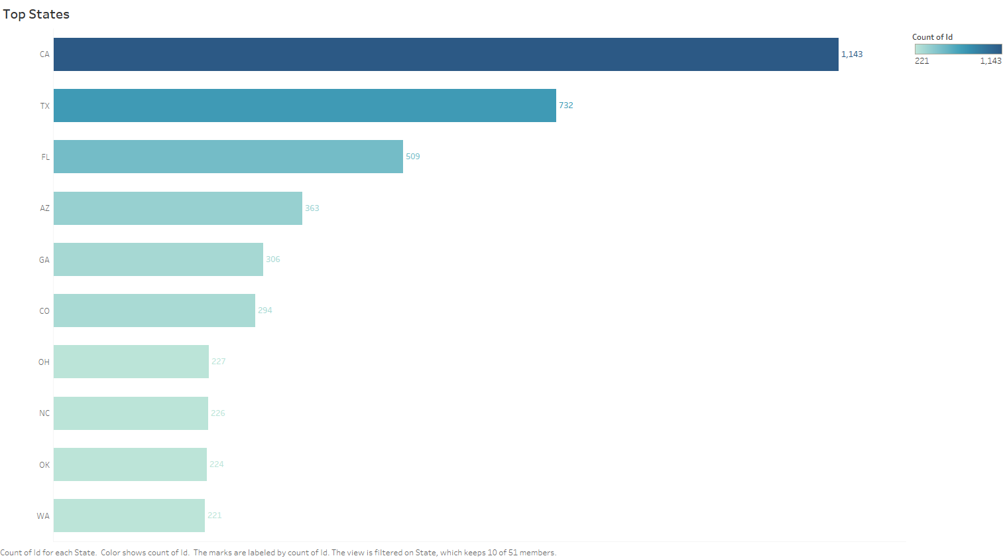

Chart 2: Age Distribution of Victims
This chart illustrates the distribution of victims' ages in fatal police shootings. The highest number of shootings is seen in the 15-30 age group, with a peak at around 30 years. This chart uses aggregation to show the total count per age group and includes details on the average age of victims.
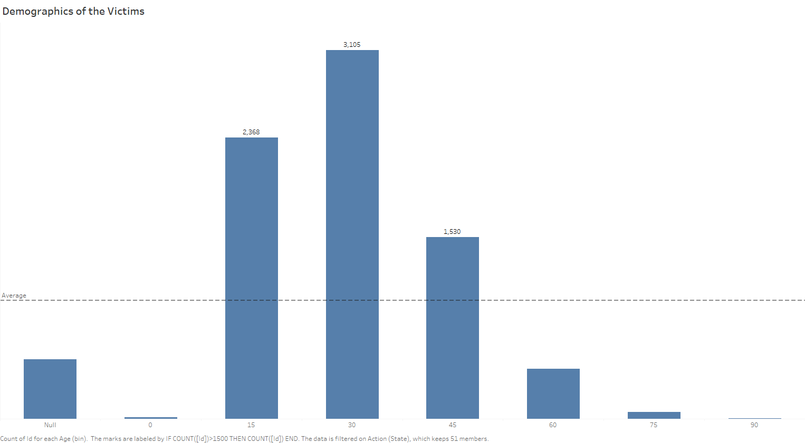
Chart 3: Weapons used
This chart shows the distribution of the types of weapons involved in fatal police shootings. Most victims were armed, with guns being the most common weapon (4,573 incidents), followed by knives (1,142 incidents). This chart highlights the need to address the circumstances and responses in cases where the victim is armed.
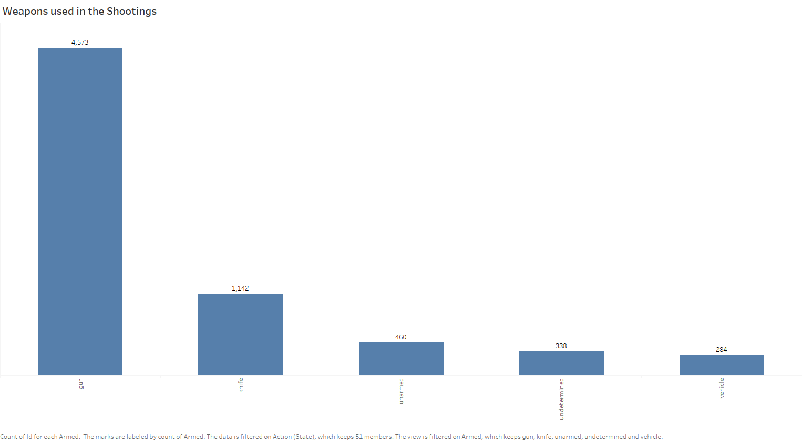

Features Incorporated:
- Aggregation and Granularity: Aggregated data by state, age group, and weapon type to show total counts.
- Ranking and Sorting: States and weapons ranked by the number of shootings in descending order.
- Marks Card: Used color and detail marks to distinguish between different demographic groups, states, and weapon types.
- Function: Date function to filter and analyze data from 2015 to 2022.
- Interactivity: Interactive filter to allow users to select a state and update all related charts dynamically.
Screenshot of the Viz:
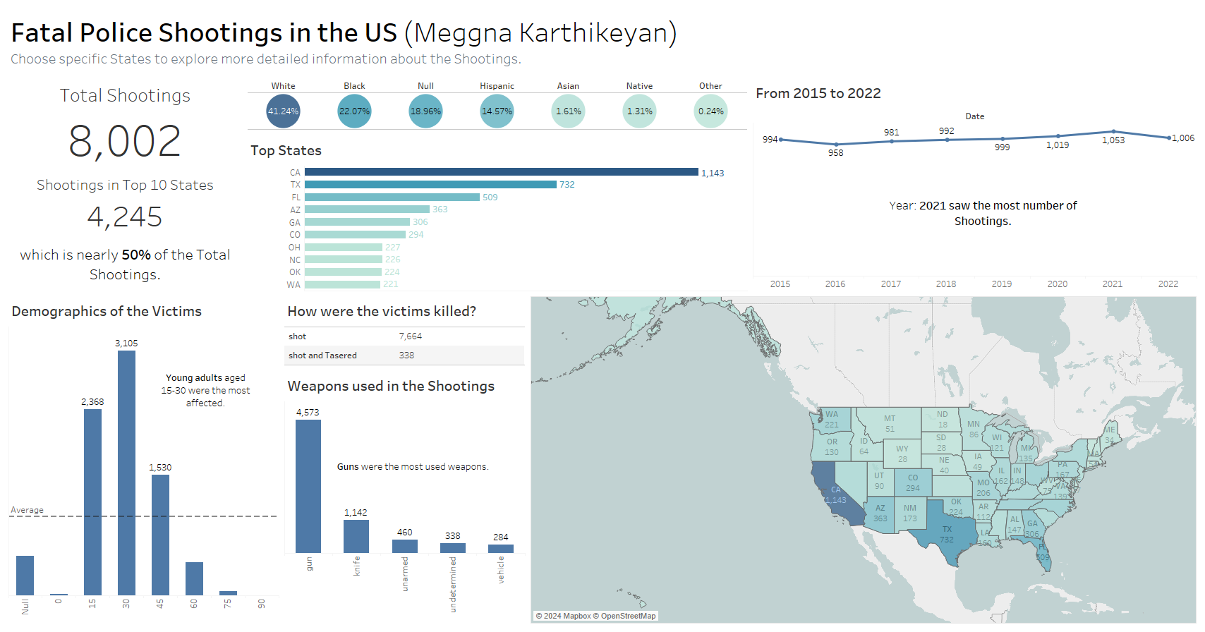
Data Source:
The dataset used for this analysis is from the Data World’s Fatal Police Shootings.
Elevator Pitch:
Here’s the link to my elevator pitch: Fatal Police Shootings Elevator Pitch
Best Regards,
Meggna Karthikeyan

